

From this column snew York is having high number of startups.

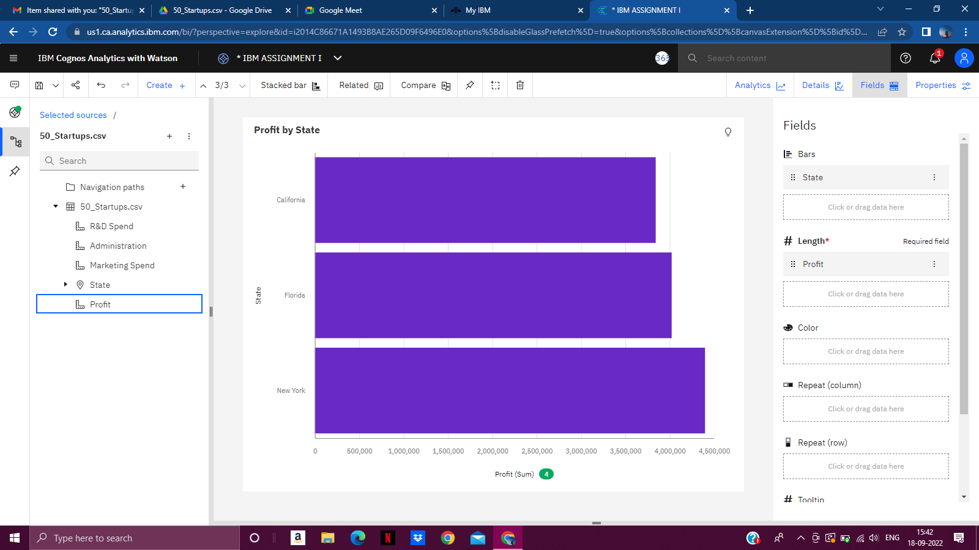

From the stacked bar New York is having high number of startups.



From this crosstab we are analyzing that If we spend on R&D then profit must be high.

Therefore,R&D spend is directly proportional to profit.

ASSIGNMENT 1 LINK:

https://us1.ca.analytics.ibm.com/bi/?perspective=explore&pathRef=.my_folders%2FIBM%2BASSIGNMENT%2FIBM%2BASSIGNMENT%2BI&subView=model0000018350150272_00000003s